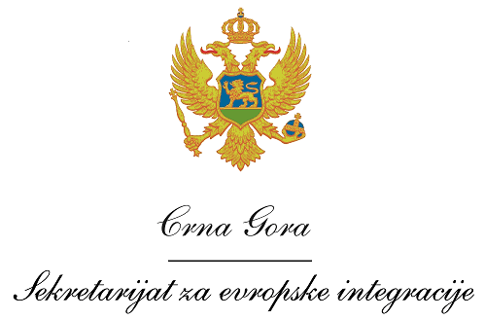
Montenegro
Prime Minister’s Office
European Integration Office

VACANCY ANNOUNCEMENT

The European Integration Office of Montenegro, in cooperation with the Ministry for Europe and Foreign Affairs of the Republic of Albania and Ministry of Local Government Administration of the Republic of Kosovo, within the IPA II Cross-border Cooperation Programmes Montenegro – Albania and Montenegro – Kosovo 2014-2020, invite the interested candidates to apply for the following positions:

- Head of the common Joint Technical Secretariat
- Financial and Procurement Officer in the common Joint Technical Secretariat
- Project Officer 1 in the common Joint Technical Secretariat
- Project Officer 2 in the common Joint Technical Secretariat
- Administrative Assistant in the common Joint Technical Secretariat

Application procedure

Interested candidates have to submit following application documents:
- A curriculum vitae (CV) in Europass format (in English);
- A motivation letter in English;
- Photocopy of the University degree;
- Photocopy of a valid driving licence.

The deadline for submission of the application documents is 29 November 2019 until 14.00 to the following e-mail address: jasna.bulatovic@gsv.gov.me, with the reference to which position the candidate applies.

Terms of Reference for above mentioned positions may be found on the following links: www.kei.gov.me; www.eu.me.

Only short-listed candidates shall be contacted for an interview.

