

**Republika e Kosovës**

**Republika Kosova-Republic of Kosovo**

*Qeveria - Vlada – Government*

*Ministria e Pushtetit Lokal*

*Ministarstvo Lokalne Samouprave*

*Ministry of Local Government*

M U N I C I P A L P E R F O R M A N C E M A N A G E M E N T S Y S T E M

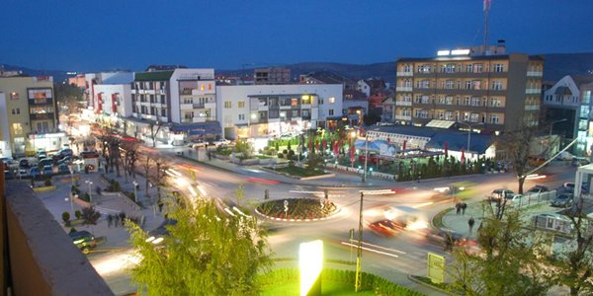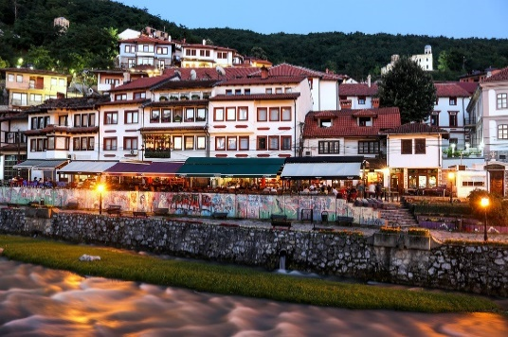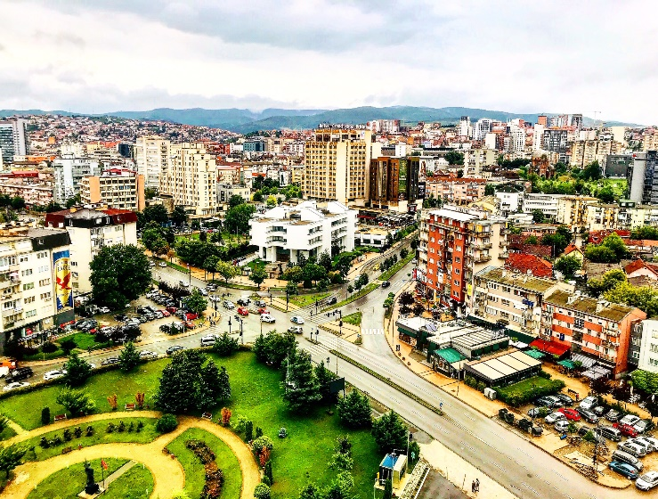

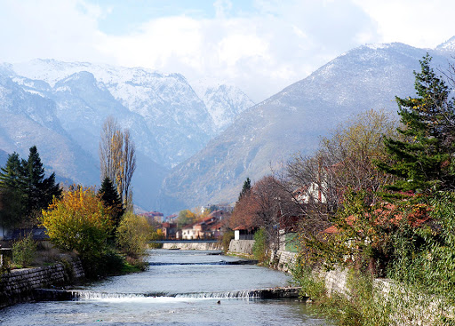

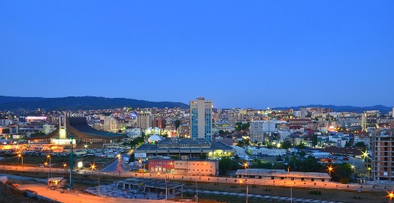

MUNICIPAL PERFORMANCE REPORT

FOR THE YEAR 2019

September, 2020

**Compiler of the report:**

Ministry of Local Government

**Supervision:**

Rozafa Ukimeraj, Secretary General of the MLG,

**Data processing:**

Department for Municipal Performance and Transparency

The report (general part) was drafted by:

**Diellor Gashi,** Head of the Department for Municipal Performance and Transparency

**Collection, processing, verification of data and drafting of individual reports of municipalities was performed by:**

Lazar Mitic, Performance Measurement and Evaluation Officer, MPL

Haxhi Krasniqi, Senior Officer for Performance Measurement and Evaluation, MLG

Edina Ibishi, Performance Measurement and Evaluation Officer, MLG

Shqiponja Vokshi, DEMOS

Jetmir Bakija - Consultant / DEMOS

Berat Abdiu – Consultant / DEMOS

Arbnor Imeri – MLGA /DEMOS

Gresa Sheqiri – MLGA /DEMOS

**Copyright 2020:**

*All rights reserved. No part of this document may be copied, reproduced or used in any form (electronic or hardcopy) or summarized without prior written authorization by the author – MLG.*

**Content**

Introduction 4

Purpose 5

Chapter I 7

1. LOCAL GOVERNMENT PERFORMANCE BASED ON MUNICIPAL PERFORMANCE MANAGEMENT SYSTEM (MPMS) 7

2. Summary of performance by municipality 10

CHAPTER II 11

Analysis of indicators by areas 11

Area 1: Public Administrative Services 11

Area 2 – Municipal Transparency 12

Area 3 – Municipal Accountability 13

Field 4 – Equality in Employment, Social and Family Services 14

Field 5 – Culture, Youth and Sports 14

Field 6 – Disaster management 15

Field 7 – Spatial Planning 15

Field 8 – Public Spaces 15

Field 9 – Road Infrastructure 16

Field 10 – Public transportation 16

Field 11 – Public Parking spaces 17

Field 12 - Drinking water 17

Field 13 - Sewerage 18

Field 14 – Waste Management 19

Field 15 – Environmental Protection 19

Field 16 – Gender Representation 19

Field 17 - Pre-University Education 20

Field 18 – Primary Health Care 21

Field 19 – Local Economic Development 22

Conclusions and recommendations 22

Annex: % of indicators by fields 25

# Introduction

The Municipal Performance Report presents performance results through 19 fields of competence that are under the responsibility of municipalities. Last year, the system went through a full review process, as foreseen in the Ministry's annual work plan. The objective of developing the municipal performance system was to include as many fields of municipal competencies and indicators that aimed, firstly, to reflect the real state of public service delivery, and secondly the results obtained to serve as important data sources for improved governance in sectors in need.

The review process produced significant changes, both in terms of the content of the measurement components and in terms of legal regulations. In step with the system review, a new Regulation on the municipal performance management system was drafted. This regulation integrated the performance measurement system with the performance-based grant scheme. At the same time, the provisions for the implementation of the electronic system for municipal performance management were defined. Furthermore, from a system with 14 fields and 77 indicators, the system was expanded to 19 fields containing 119 indicators.

Even in this cycle of performance measurement and evaluation, the scope of data reflects the performance of municipalities within indicators, results (or sub-objectives) and *fields* according to their respective competencies.

Municipal performance is based on data provided and documented by the municipalities themselves. This report presents the performance only for 2019 and in many cases draws comparisons with the performance of previous years. The report aims to highlight two key issues of public affairs management: 1) The way of governing municipalities assessed according to the applicable legislation and 2) The provision of services in terms of quantity and quality, when possible.

The data serve to reflect the performance within the municipality, to make comparisons about the development trend of local government in general and contain important elements of accountability of local elected officials to the citizens. The report also informs citizens about the reasonable expectations of service delivery from their local institutions.

However, it is up to the local institutions to decide on their work priorities, how to provide services to citizens and the commitment of relevant resources. The report draws general conclusions on the level of performance of municipalities and provides relevant recommendations for improving services based on applicable legal rules or required governing standards.

Legal basis for the performance report

MPMS is regulated by the Regulation of the Ministry of Local Government no. 01/2020 on the Municipal Performance Management System and the Municipal Performance Grant Scheme.

The system is built based on eight basic principles:

• The principle of legality;

• The principle of transparency;

• The principle of subsidiarity;

• The principle of merit;

• The principle of efficiency and effectiveness;

• The principle of validity;

• The principle of equality; and

• The principle of applicability.

The regulation defines the right of the supervisory authority to request information which serves to measure and evaluate the performance of municipalities. The regulation defines the organizational structures responsible for reporting to municipalities within the MPMS.

# Purpose

Performance measurement is not simply about collecting data related to a predetermined short-term performance goal. The purpose of this measurement is to highlight the fields where utilities need improvement and advancement, as well as the fields where medium and long term investments should be oriented. If this performance system is used properly, the data can help municipalities improve their planning and orient their priorities in the sectors needed for the coming years.

The system also serves the central authorities to plan projects according to realistic estimates, criteria based on the need for investment and fairer distribution of public money.

Although this performance system comes with a performance grant consisting of the Ministry's budget and donor budgets, the greatest effect of performance enhancement may be as a result of recording, comparing and publishing data from different fields of government. In fact, performance measurement aims to answer the following questions:

* How well are the municipalities performing?
* Whether the municipalities are achieving their goals or not?
* Whether the management processes are in the right direction?
* What are the necessary improvements to be made?

Therefore, through such evaluations and monitoring of the work of the administration in general, or even local elected officials, it is assumed to increase the level of responsibility and accountability, so that all this is reflected in better governance and quality services.

Methodology

The municipal performance management system is built by MLG in cooperation with international partners. MLG has defined and regulated the methodology for preparation, collection, processing, verification and reporting of data in the Municipal Performance Management System.

Guidelines for data collection and reporting are provided through: training for municipal performance coordinators and reporting officers. In step with this, written instructions have been prepared by explaining in detail the entire scenario of the functioning of the MPMS.

The report preparation process was done through the following steps:

1. Preparation of the MPMS database;
2. Development of methodology for data quality assurance;
3. Distribution of forms and instructions for reporting to municipalities;
4. Holding trainings for municipal coordinators;
5. Opening of the reporting period;
6. Reporting by municipalities;
7. Data collection by municipalities;
8. Data processing, cleaning and analysis;
9. Completion of the data verification and documentation phase;
10. Finalization of the report.

Reporting and documenting data for MPMS was done by municipalities following the instructions of the MLG. The work of collecting, documenting and reporting data within the various municipal institutions is coordinated through a municipal coordinator of MPMS who is assigned to each municipality. Whereas, the Mayors have authorized the final data for reporting to the MLG.

Prior to the finalization of the report by the MLG, the processed data were sent to each municipality having the opportunity to correct and provide remarks.

The accuracy of the data presented in this report is the responsibility of the municipality. MLG has verified the reported data in two forms:

* Documentation through monitoring of official websites;
* Review of official documents attached to the completed forms;
* Review of additional documents required for certain data;
* Comparison of data with other official documents of public institutions.
* Comparison with other official reports of MLG.
* For certain data, the responsible officials in the municipalities have been contacted directly.

In this cycle, 36 municipalities reported, while 2 municipalities (Mamusha and Dragash) did not provide data.

Some of the data reported by Serb-majority municipalities, especially in the field of education and health, that did not correspond with the provision of services based on the legislation of the Republic of Kosovo, have been marked as void and a value of 0% of performance was applied.

# Chapter I

# 1. LOCAL GOVERNMENT PERFORMANCE BASED ON MUNICIPAL PERFORMANCE MANAGEMENT SYSTEM (MPMS)

Local self-government is a fairly broad filed for the exercise of public authority. The activity of municipalities is diverse and quite complex. The most frequent contact of citizens with the state is done through the municipal administration. Municipalities face numerous requests from citizens and other stakeholders. It is no coincidence that our time is called 'administration time'. The large volume of requests submitted by citizens, made the administrative activity of the responsible bodies in the municipalities to be quite active. Due to the high density of citizens' requests, any form of supervision of the activity of municipal bodies, would promote the level of responsibility in order to increase the efficiency of service delivery.

Nineteen fields of the municipal performance management system summarize a fairly wide range of municipal competencies. Furthermore, they express the set of rights and obligations that municipalities exercise to serve citizens on the basis of legal competencies[1]. The indicators used provide considerable information on the level of services provided. The data obtained from this system provide clear indications to the municipal management and stakeholders about the interventions, the extension of priorities and the achievement of the intended objectives. Therefore, the analysis of the data obtained from this process should go through an evaluation process by the municipal authorities, to review them systematically and objectively, as well as to reflect on concrete measures through subsequent governance programs and level of priorities.

To promote the improvement of service delivery by municipal bodies, the Municipal Performance Management System was established and since 2009 performance measurements have been applied. The system has evolved over the years being supplemented with new fields, results and indicators. The special measurement and evaluation of this year is the Quality Assurance System, based on more rigorous data verification instruments.

Likewise, this year the base of the performance system has been expanded with new fields, due to the strategic priorities of the country and the need for support in specific fields of municipal competencies. In this case, the system also incorporated the fields of pre-university education, primary health and local economic development[2]. At the same time, the field of gender equal representation was integrated, as well as in general a system of building indicators according to gender components.

Of course, the performance of municipalities from year to year has been increasing. If the performance is analyzed in the middle of 2017-2018, then there is a positive trend of municipal achievements. In contrast to 2017, where the percentage in 14 fields was 60.5%, in 2018 municipalities marked progress of 5.5%, or 66% in total. Full comparisons with 2019 have not been possible, due to the large change in fields and indicators. However, if we evaluate the ratio between fields with similar indicators, the results show a decrease of 4.8% compared to 2018. This is due to many factors, but mainly the change of measuring instruments and new indicators incorporated within the fields. Also, the different number of municipalities that have reported over the years, results in the overall level of performance. The following is a figure with the percentage of performance in 14 fields over the years (excluding 4 new fields:

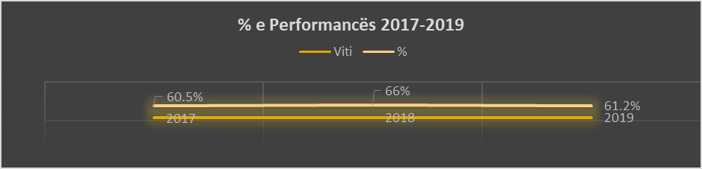

% of performance 2017-2019

Figure 1. Performance of municipalities by fields during 2017, 2018, 2019

According to the data, during 2019 the overall performance of municipalities in 19 fields with 119 measurement indicators is 58.79%. The field with the highest performance is the management of natural and other disasters with 77.19%, while the lowest is in the sewerage, with 36.51%.

ACCIDENT MANAGEMENT

MUNICIPAL TRANSPARENCY

DRINKING WATER

PUBLIC ADMINISTRATIVE SERVICES

WASTE MANAGEMENT

CULTURE, YOUTH AND SPORT

ENVIRONMENTAL PROTECTION

PUBLIC TRANSPORT

MUNICIPAL RESPONSIBILITY

LOCAL ECONOMIC DEVELOPMENT

AVERAGE

EQUALITY IN EMPLOYMENT, SOCIAL SERVICES AND… PUBLIC SPACES

PRE-UNIVERSITY EDUCATION

ROAD INFRASTRUCTURE

PRIMARY NURSING

SPATIAL PLANNING

PUBLIC PARKINGS

GENDER REPRESENTATION

SEWERAGE

% by fields

Figure 2 Performance of municipalities in 19 fields of measurement during 2019

Drinking water stands better than other fields[3] with the performance of 72.93, and also waste management at the level of 69.25% is in the same ranking as last year, but for 14.06% lower expressed in percentage.

Municipal transparency in 2019 turns out to be in second place compared to other fields. Compared to the previous year, this field is lower in terms of percentage (76.23% in 2018), but at a higher level in terms of ranking compared to other fields. In this field, the data show a good level of achievement of municipalities in publishing notices, regulations, decisions, budget plans and procurement. In 2019, the direct publication of municipal assembly meetings and the uploading of video recordings on their official websites was applied. The publication of contracts has been increasing in recent years, so there are improvements in this field. However, the performance of 72.93% indicates that municipalities need to increase the intensity of their work to be fully transparent.

Even during 2019, municipalities have shown efficiency in handling cases in administrative proceedings at the rate of 70.47%. This indicator reflected the indicator for the provision of electronic services. The field of transparency is closely related to the field of municipal accountability, which is assessed by a large number of indicators within the KPSS. Unlike transparency indicators which are mainly oriented towards providing the opportunity to be as close as possible to the information base, municipal accountability contains indicators aimed at measuring the accountability of municipal bodies as well as their activity to ensure the active involvement of citizens in decision-making and public processes, to shape what in theory is known as consensus governance.

Maximum performance

77.19 %

1. Equality in employment, social and family services;

2. Public spaces;

3. Primary health care;

4. Road infrastructure;

5. Spatial planning;

6. Public parking lots;

7. Gender representation;

8. Sewage

1. Disaster management;

2. Drinking water;

3. Municipal transparency;

4. Administrative Services;

1. Waste management;

2., Youth, Culture and Sports;

3. Pre-university education;

4. Environment protection;

5. Public transport;

6. Municipal responsibility;

7. Local Economic Development;

Figure 3. Grouping of areas based on the level of performance

Thus, while municipal transparency is relatively good, municipal accountability at the level of 62.64%, indicates that the accountability of municipalities to citizens should be further strengthened. In particular, the new rules on minimum standards for public consultation should be implemented, which define the ways and means for conducting public consultation during the drafting of projects or policies at the local level.

Municipalities have performed at a medium level in cultural, youth and sports activities, environmental protection, provision of local public transport and social services. The sectors assessed at a low level that need improvement are within the field of sewerage, ie in wastewater treatment, then the field of equal gender representation, pre-university education (especially in preschools), primary health care, spatial planning , but also the improvement of sewerage and road infrastructure. Despite the development of the legal and strategic framework for gender equality, the data provide low values of equal representation of both genders in local government sectors. Gender equal representation has taken into account not only the inclusion of women in employment in the public sector, but also their access to other sectors. Indicators in this field have been extended to local gender equality plans, women's access to municipal subsidies or incentive schemes for business development, representation in local councils, municipal bodies (commissions) and others.

On the other hand, the assessment within the fields with indicators of public services, emphasizes the need for new strategic orientations of municipalities to support the weakest sectors of government. Although the sewerage field remains at an unsatisfactory level (36.51%), the municipalities are implementing sewerage network expansion projects every year, but there are also plant construction projects that are being completed. Investments in this field, regardless of cost, should be an ongoing priority, given the importance of avoiding water and environmental pollutants in general. Also, 71.83% of local roads are paved, emphasizing the need to expand road infrastructure in all settlements of municipalities. Furthermore, roads should be completed with accompanying infrastructure, ie sidewalks (currently 9.15%) and public lighting (15.03%). Despite the fact that at the general level of municipalities it is estimated that there are sufficient spaces for students, the need to create additional school spaces is more pronounced especially in urban fields. At the same time, the completion of schools with infrastructure, teaching equipment and tools is necessary, given that only 49.26% of schools nationwide meet the required standards, including the necessary ICT equipment or cabinets.

# 2. Summary of performance by municipality

The municipal performance management system is a comprehensive platform for collecting, systematizing, analysing and reporting municipal data in various areas of municipalities' own competencies. Measuring the performance of municipalities has a multifaceted impact, especially in improving the quality of service delivery. Studies conducted by the Organization for Economic Co-operation and Development (OECD) on civil service reform in 29 different countries of the world have shown that performance management is a key factor in many cases, especially in achieving the objectives of institutions. Furthermore, performance measurement and evaluation help municipalities in gaining experience within municipalities but also between municipalities by comparing their work from year to year and creating the opportunity to improve their work.

This performance evaluation cycle focused on reflecting the achievements of 38 municipalities. 36 municipalities responded to the request for reporting, with the exception of the municipalities of Mamusha and Dragash which did not submit reporting forms. The ranking of municipalities is done taking into account the level of achievements according to the indicators. This is because the evaluation according to the indicators is considered to be more objective due to their weight, influenced by their volume within the given field.

Compared to the previous period, in general there are no changes in municipalities based on the performance achieved. The overall average of municipalities based on the indicators is 61.16%. There are 22 municipalities that have achieved performance above the overall average, while 13 municipalities are below average.

The following is the figure of the ranking of municipalities according to the performance of indicators:

**% by indicators**

61.16 %

Overall average

Figure 3 Percentage of municipalities achieved in 119 indicators

According to the percentages presented in Figure 3, we notice that the municipality with the highest performance is Gllogoc with 77.04%, followed by Hani i Elezit with 75.78 and Rahovec with 75.20%. It should be noted that with the review of indicators for this reporting year, the performance of many service indicators is measured per capita in the municipality, or per square kilometer of the respective municipality.

18 municipalities

13 municipalities

Maximum performance

77.04 %

2 municipalities

3 municipalities

Figure 5. Grouping of municipalities based on the level of indicator performance

The figure above shows 13 municipalities with high performance of 66-80%, 18 municipalities with average performance between 40-66%, 2 municipalities with low performance 20-40% and 3 municipalities with performance lower than 20%. Referring to the characteristics of municipalities, high achievement is mainly dominated by medium-sized municipalities.

Regarding the indicators used, in total there are 8 indicators with performance over 90%, as follows: 1) Reviewed administrative requests during the year (92.66%); 2) Suspension of municipal officials in relation to the indictments filed against them (93.06%). 3) Public Hearings on the Mid-Term Expenditure Framework and the municipal budget (90.51%); 4) Filling vacant positions in education with open vacancy announcments (90.47%); 5) Following of legal procedures for the selection of school management staff (principals and deputy principals) (91.11%); 6) Prevention of school dropout by students (97.17%) etc. Other indicators where the performance is between 80-90% are: 1) Application of the schedule for waste collection (87.77); 2) Timely approval of the annual budget of the municipality in the Municipal Assembly (88.61%); 3) The level of citizens' access to public documents (87.31%); 4) Administrative requests reviewed within the legal deadlines (88.19%), 6) Reviewed requests for construction permit (85.55%), 7) Children in need of shelter who have been provided with family shelter&housing (85.34%). In addition, indicators that are not fully met or have been met in a very low percentage are: 1) Publication of reports of the results of public consultations (0%)[4]; 2) Kindergartens in rural areas per 10000 inhabitants (1%); 3) Roads in the urban area with bicycle paths (5.89%); Gender equality in the composition of local councils (6.40%); Registration of ownership in the name of both sexes (12.17). (See appendix 1).

Nr. I Treguesëve %

No. of Indicators %

Figure 6 Grouping of indicators based on the level of performance

**E mesme   
(40-70%)**

**47**

17.3.7 97%

18.3.2 95%

17.3.2 95%

17.3.8 94%

17.3.3 94%

3.4.2 93%

1.1.1 93%

17.2.6 91%

3.1.4 91%

17.2.5 90%

3.2.1 89%

1.1.2 88%

14.2.1 88%

17.2.4 88%

2.1.2 87%

6.1.2 86%

7.2.1 86%

4.2.2 85%

3.2.2 85%

3.5.2 84%

3.1.1 83%

17.2.1 83%

16.1.1 81%

17.3.6 79%

5.2.1 79%

14.1.1 78%

2.2.1 78%

3.3.1 78%

2.1.4 77%

15.1.2 76%

8.1.3 75%

3.2.4 75%

13.1.1 75%

17.3.5 75%

12.1.2 74%

7.2.2 74%

14.2.2 73%

3.5.1 73%

3.3.2 73%

12.1.1 72%

9.1.1 72%

18.1.1 71%

13.1.2 71%

2.1.3 71%

19.1.3 70%

2.2.2 70%

14.1.2 70%

7.2.3 70%

18.2.1 70%

6.1.1 68%

18.3.3 68%

5.1.1 68%

8.1.2 67%

3.1.3 67%

16.2.4 67%

10.1.1 67%

9.2.5 66%

17.2.2 66%

10.1.2 65%

3.1.8 65%

16.1.4 65%

9.1.3 65%

2.1.5 65%

15.1.1 64%

17.1.5 64%

3.2.6 62%

10.1.3 60%

4.2.1 60%

19.1.2 60%

17.3.4 60%

4.1.2 59%

2.1.1 59%

16.1.2 59%

17.1.3 58%

3.1.7 58%

17.1.6 58%

5.2.2 57%

15.1.3 57%

11.1.3 56%

19.1.1 56%

9.1.2 55%

3.1.6 54%

3.1.2 54%

9.2.3 53%

19.1.4 52%

16.2.1 51%

16.1.3 51%

17.1.4 51%

11.1.4 50%

14.3.1 50%

3.5.3 50%

3.2.3 50%

16.2.3 47%

17.1.2 42%

Maximum performance per indicator

97%

Nr. I Treguesëve %

11.1.2 15%

9.2.2 15%

7.1.1 14%

16.3.2 12%

8.1.1 12%

16.3.1 12%

9.2.1 9%

17.2.3 7%

16.1.5 6%

18.2.2 6%

9.2.4 6%

17.3.1 1%

17.1.1 1%

3.1.5 0%

13.2.1 0%

Nr. I Treguesëve %

18.3.1 37%

18.1.2 36%

16.2.2 36%

3.2.5 32%

1.1.4 31%

3.3.3 30%

3.4.1 28%

11.1.1 26%

4.1.1 23%

**E lartë   
(70-100%)**

**48**

**E ulët  
(20-40%)**

**9**

**Shumë e ulët  
(0-20%)**

**15**

# CHAPTER II

# Analysis of indicators by areas

## Area 1: Public Administrative Services

This area consists of four indicators, including a first-time added indicator. The area includes public administrative services (PAS) and the management of the requests of citizens, natural and legal persons to municipal bodies for issues related to the competencies of municipalities and which pass through the One-Stop-Shop in the Municipality. At the same time, this area measures the willingness of municipalities to offer these requests online or through e-kiosks.

Compared to 19 other areas, this area ranks fourth in terms of performance, with an overall level of 70.47%, compared to 92.6% in 2018.

Administrative services - % by indicators

Administrative services provided in electronic form by the municipality

Administrative requirements considered within the legal deadline

Administrative requirements considered during the year

Figure 4 Performance indicators in the field of administrative services

The data show that the municipalities have largely reviewed the administrative requests that have been submitted to them. There are about 2,254,947 million administrative requests that municipalities have received during 2019, of which 2,158,438 requests have been reviewed. The average processing of requests for the municipality is 42612.5 requests. These include applications for various municipal permits, civil status documents, requests for access to information, and civic requests for funding and addressing. 92.66% of them found answers, while 88.19% of them found answers within the legal deadline.

Referring to the performance by municipalities in this area, the highest percentage in meeting the indicators is in the Municipality of Rahovec with 96.50%, while the lowest is in the Municipality of Shterpce at 29.35%. In addition, the Municipality of Zubin Potok and North Mitrovica did not report in this area, where its performance was calculated at 0%.

% of provided administrative services by municipalities

Figure 5 Comparison of municipal performance in the field of administrative services

However, it should be noted that for the reporting year the indicator for the provision of online administrative services has increased and this has resulted in a decrease in overall performance in this area.

Electronic services indicators provide data for a low level of development of administrative procedures in this form. However, it is noticed that municipalities have started to apply platforms for providing online services, some of which are integrated into their official websites, or through e-kiosks. According to MPMS data which measure the level of online application for 10 certificates, permits or invoices, the level of service provision in this form is 30.56%. This form of service delivery reduces the cost of the municipality in their treatment, increases the efficiency in their timely treatment, and enables the administrative services to be provided without the need to have direct contact with municipal officials. The provision of online administrative services should be started by municipalities that have not yet taken such initiatives, while it should be extended to municipalities that have started to provide some certificates of marital status or utility bills.

## Area 2 – Municipal Transparency

Although this area has previously been with 16 indicators, in 2019 it was restructured into two parts: Municipal Transparency and Municipal Accountability. This area now has seven indicators aimed at achieving results in ensuring access to municipal data, attending assembly meetings, raising information standards through websites, budget transparency, and public procurement.

The overall performance achieved in the field of transparency is 72.93%, unlike the previous year where it was 76.2%. In terms of performance according to indicators, the highest percentage is in allowing citizens access to official documents expressed by 87.31%.

% of transparency indicators

Publication of public procurement documents and contracts

Publication of documents for budget planning and spending

Publication of acts of a general nature, adopted by the mayor on the official website

Publication of acts adopted by the Municipal Assembly on the official website of the municipality

Fulfilling the criteria of the official website of the municipality

Level of access to public documents by citizens

Public assembly sessions and with live online broadcast

Figure 6 Performance indicators in the field of transparency

From the above figure, it can be seen that the indicator for live online broadcasting of assembly meetings comes out at the level of 57.35%, which also affects the reduction of overall performance in this area. The eight criteria for the municipal website appear to have been met in the amount of 70.83%, while the acts of the municipal assembly are published in the amount of 77.37%. The data show a positive trend in the publication of acts of a general character approved by the mayors.

Also, municipalities are mainly transparent in publishing the municipal budget and expenditure reports, however, there is inconsistency in the format of the budget and financial reports published by municipalities. The annual public procurement plan appears to have almost all municipalities while only eight of them have not published any report on the implementation of this plan.

% of municipalities achievements in the field of transparency

Figure 7 Comparison of municipal performance in the field of transparency

The figure above shows 16 municipalities which have shown performance between 90-100% in the field of transparency, of which: Vushtrria (100%), Kaçanik (100%), Gllogoc (100%), Peja (99.89%), Rahovec (98.95%), Lipjan (98.75%), Ferizaj (98.13%). There are 4 municipalities which still do not use official websites as an official source of information.

## Area 3 – Municipal Accountability

Municipal accountability is included as a new area in the MPMS and has a total of 22 indicators. This field has an overall performance of 62.64%. Within this area, we note the high performance of municipalities in suspending officials who have been indicted in connection with offences of misuse of official duty. According to the data, an indictment for such criminal offences was filed against 28 officials in 9 municipalities, of which 13 or 46% were suspended. However, the percentage at the indicator level was affected by the large number of municipalities that did not have cases with indictments for public officials, which according to the MPMS is considered a positive performance, increasing the percentage level to 93.06%. Municipalities have also shown positive performance in discussing draft budgets and the medium-term expenditure framework. According to the data, in 36 municipalities, 280 meetings were held with citizens for the draft budget or an average of 8 meetings per municipality. The following is a list of indicators in this area by percentage:

Accountability indicators in %

Employees with special needs in institutions…

Contracts for special services are in accordance with…

Jobs processed through…

Application of the assessment distribution scheme…

Suspension of municipal officials in relation to indictments…

Reporting the integrity work plan to…

Level of referral of recommendations of the National Office…

Level of processed payment slips within the legal deadline of…

Level of implementation of the procurement plan

Assembly sessions with the participation of the mayor…

Discussion of the internal auditor's report and plan…

Discussion on the external auditor's report and plan…

Discussion on municipal performance from…

Discussions on quarterly budget reports from…

Timely adoption of the draft annual budget of the municipality

Interventions in sewer cracks

Local communities that held at least 6 sessions a year

Publication of reports on public consultation processes…

Public hearings on SOB and municipal budget

Municipal acts and local policy documents…

Citizen participation in public consultations

Publication of notices for holding 2 public meetings

Figure 8. Performance indicators in the field of municipal accountability

From the data of the above figure it appears that most municipalities do not have this drafted and as a result have not submitted to the municipal assembly the annual integrity plan. A low level of discussion of the report of Internal Auditor has been seen and action plan for addressing the recommendations. Despite the legal obligation of municipalities to discuss the performance report for the previous year in the municipal assembly, the provision of the relevant regulation has been respected only to the extent of 50%. Whereas the new provision of the administrative instruction on the minimum standards of public consultation at the local level has not yet started to be published, to publish the reports with the results of the public consultation processes, through which citizens would receive responses to address their proposals from the responsible bodies of the municipality. Citizen participation in public consultations is quite low despite the standard of 3% of the population of the municipality. It has been reported by municipalities that 27423 citizens have participated in public consultation processes, or 760 per municipality. Of course there are some municipalities such as Suhareka, Vitia, Skenderaj, Oblic, where the participation is higher compared to the population of these municipalities. Regarding the level of implementation of the procurement plan, based on the amount spent against the planned amount, the performance results in 77.64%.

Achieved % by municipalities

Figure 9. Comparing the performance of municipalities in the field of accountability

The highest performance in the indicators of this field has been achieved by the municipalities of Lipjan and Kacanik. The municipalities of Gllogoc, Elez Han and Rahovec are also at a high level. In contrast, the municipalities of North Mitrovica, Strpce, Zubin Potok and Novo Brdo are lower. The poor level of performance in this field has also been affected by the non-reporting of all data on indicators by the municipalities in question.

## Field 4 – Equality in Employment, Social and Family Services

This field of two outcomes and four indicators covers the representation of different groups in municipal employment, as well as the social services of the most groups in needs in the municipalities. Within employment, indicators measure the level of employment of persons with disabilities in municipal institutions, as well as the percentage of inclusion of non-majority communities. Overall performance in this field is 57.70%.

Children in need of shelter and provided with family shelter

Families with needs who are provided with housing and conditions have been created for the release of social housing

Employees from non-majority communities

Employees with special needs in municipal institutions

% of indicators

Figure 10. Performance indicators in the field of Equality in Employment, Social and Family Services

According to the data, the level of fulfilment of the quota for employees with special needs is quite low. Law No. 05L-051 on protection against discrimination, stipulates that all are equal in employment, where employers must take appropriate measures to enable the person with disabilities to access, participate in or advance in employment, if this measure constitutes a disproportionate burden on the employer. Also Article 12 of the Law No. 03/L-019 on training, vocational rehabilitation and employment of persons with disabilities requires that every public institution employs one person with disabilities for every 50 employees (or 2% of employees). Measuring this indicator is a legal priority given that most public institutions have not met this obligation. According to the data declared by the municipalities on the number of employees in municipal institutions out of a total of 37,310 employees, 161 were declared to have special needs, while 1757 from the ranks of non-majority communities. Meeting social housing requirements is below 60.28% and there are very few families leaving social housing.

Achieved % by municipalities

Figure 11. Comparing the performance of municipalities in the field of Equality in Employment, Social and Family Services

## Field 5 – Culture, Youth and Sports

Within this field, municipal cultural, youth and sports activities are measured, as one of the own competencies of municipalities. The field also covers services provided by municipalities related to culture, youth and sports, including sports facilities.

This field measures performance by comparing it to the number of inhabitants for reasons of being more balanced towards municipalities with many inhabitants and those with fewer inhabitants. This field has an overall performance of 67.99%.

% of indicators in the field of culture, youth and sports

Citizen participation in cultural, youth and sports activities

Activities of culture, youth and sports, organized by the municipal budget

Premises for sports activities by number of inhabitants

Figure 12. Performance indicators in the field of culture

The MPMS standard for at least one culture, youth and sports activity per 100 inhabitants in the municipality is reached at level of 79.2%. Whereas space for sports activities per number of inhabitants is reached in the rate of 68.2%. According to the data, about 2300 cultural and sports activities have been organized in 33 municipalities. Citizen participation in these activities compared to the number of inhabitants is 57.37%.

Achieved % of municipalities in the field of culture

Figure 13. Comparative data between municipalities in the field of culture

## 

## Field 6 – Disaster management

This field measures the planning, organization and management of the organized system of the municipality to respond to phenomena caused by uncontrolled powers and other powers. The field has only one result and two indicators, which mainly assess the implementation of the plan for protection from natural disasters, as well as the level of responses of municipal institutions to cases presented in this field. Overall performance in this field is 77.19%.

Interventions to protect against inconvenience

Level of implementation of the municipal plan for management of inconveniences

% of indicators

Figure 14 Performance indicators in the field of disaster management

According to the data, the interventions of municipal institutions to disasters turn out to be at a level of 85.90%. Expressed in the number of cases, out of 12850 reported disasters, the responsible municipal teams have intervened in 12556 of them. Also, 68.48% of municipalities have a municipal disaster management plan and a report on the implementation of the plan. Furthermore, out of 1751 actions foreseen by the municipalities in their disaster management plans, 1599 actions were carried out. Last year, the overall performance of this field was at 83.3%, so there is a decrease in the performance of municipalities

% by municipalities

Figure 15 Comparative data between municipalities in the field of natural and other disaster management

## Field 7 – Spatial Planning

This field measures municipal spatial development through spatial planning instruments, but also the level of municipal construction planning. This field has an overall performance of 45.24%.

% of indicators

New buildings with a building permit

New inspected buildings

Applications for building permits considered

Area of the territory of the municipality covered with regulatory plans (detailed)

Figure 16. Performance indicators in the field of spatial planning

The surface of the territory of the municipality covered by detailed regulatory plans is 14.05% of the territory. Regarding construction permits, out of 5391 applications for construction permits from municipalities, 4150 applications or 85.55% of them were reviewed on time. Based on the data, new buildings for which construction permits were issued, were inspected at a rate of 73.86%.

% by municipalities

Figure 17. Comparative data between municipalities in the field of spatial planning

## Field 8 – Public Spaces

This area measures public spaces which are of interest to citizens, managed by municipalities and which affect the quality and standard of living of citizens. Overall performance according to data provided by municipalities is 51.58%. According to the Law on Local Self Government, municipalities are, among others, competent to provide and maintain parks and public spaces.

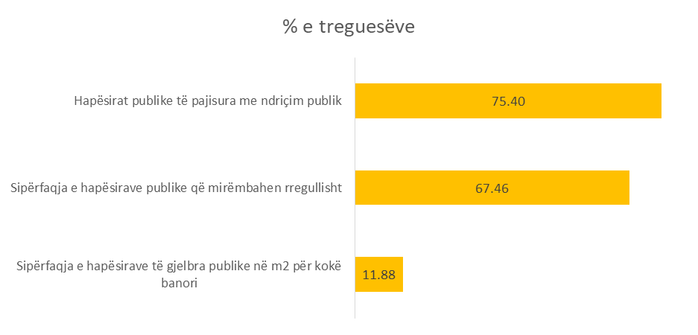

% of indicators

Public spaces equipped with public lighting

Area of public spaces that are under constant maintenance

Area of public spaces with greenery per m² per capita

Figure 18. Performance indicators in the field of public spaces

In addition to the level of green spaces per capita, this area also measures the area of public spaces which are regularly maintained by municipalities, as well as the number of public spaces that have public lighting.

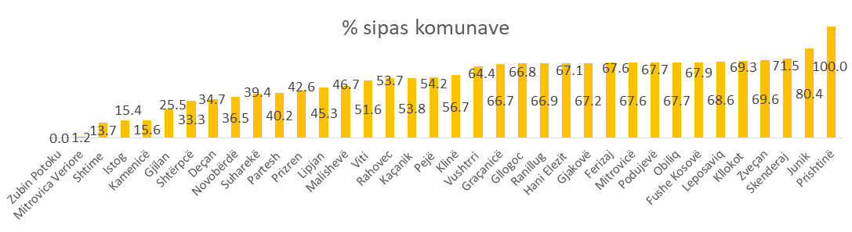

% by municipalities

Figure 19. Comparative data between municipalities in the field of public spaces

Based on the data, about 67.5% of public spaces are regularly maintained, while 75.4% of public spaces have aslo public lighting.

## Field 9 – Road Infrastructure

This area measures municipal roads and related ancillary infrastructure that are under the competence of the municipality. This area has been completed with new indicators to promote a modern road infrastructure with sidewalks, lighting and signage as well as bicycle path. Overall performance is estimated to be 46.76%.

Local re-paved roads

Roads in urban areas with bike paths

Length of local roads equipped with signalization

Length of local roads equipped with public lighting

Length of local roads equipped with sidewalks

Local roads with maintenance during the winter season

Local roads with maintenance during the summer season

Asphalted local roads

% of indicators in the field of road infrastructure

Figure 20. Performance indicators in the field of road infrastructure

What made the overall performance not be so high, is the inclusion of the new indicator for roads in urban areas with bicycle paths, which turns out to be at the rate of 5.89%.

Field level performance is presented as follows:

% in the road infrastructure

Figure 21. Comparative data between municipalities

## Field 10 – Public transportation

This area measures the provision of public transport for the citizens of the municipality. This field has an overall performance of 64.13%.

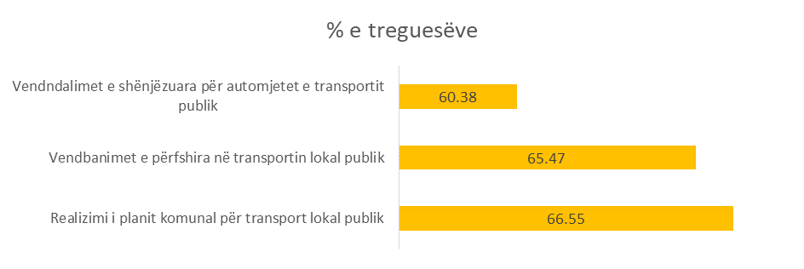

% of indicators

Marking of stopping places for public transport vehicles

Settlements included in local public transport

Implementation of the municipal plan for local public transport

Figure 22. Performance indicators in the field of public transportation

Within this area we notice above average performance for all three indicators. According to the data, the Municipalities have implemented the Municipal Plan for Public Transport in the rate of 66.55%. In addition, 11 of the municipalities [5] (small and medium) have not documented that they have drafted such a plan; otherwise 18 municipalities have implemented the plan in the rate of 100%.

In the indicator "*Settlements included in local public transportation*", 8 out of 38 municipalities in Kosovo did not report in this indicator and the average for 30 municipalities reaches the value of 65.47%, whereas the marked stops for public transportation vehicles are at the level of 60.38%.

The following is the performance of the percentage field for each of the municipalities of Kosovo:

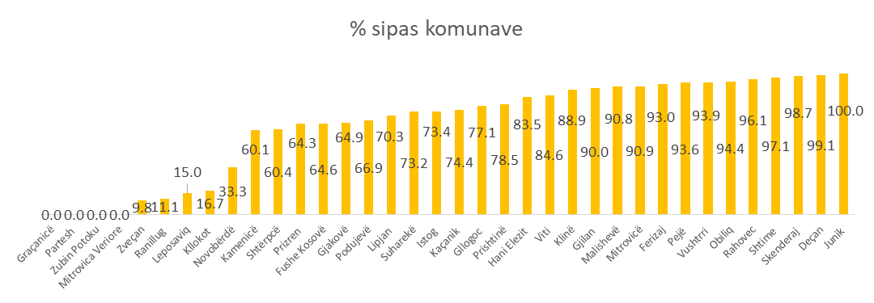

% by municipalities

Figure 23. Comparative data between municipalities in the field of public transportation

## Field 11 – Public Parking spaces

Public parking spaces are publicly and privately owned places, with a certain number of parking spaces, built to the required standards and set for parking of motor vehicles. Furthermore, this field measures the number of parking lots in the municipality and the number of parking lots against vehicles registered in the municipality, as well as how many taxi parking lots are against the number of licensed taxis and how many public parking lots have spaces reserved for people with special needs.

Field level performance is 41.34%.

Number of parking spaces reserved for people with disabilities

Parking lots for taxi drivers

Parking lots for motor vehicles on the territory of the municipality

Number of parking spaces for motor vehicles

% of indicators in the filed of public parkings

Figure 24. Performance indicators in the field of parking spaces

The number of parking lots in Kosovo level for the municipalities that have reported is 1437, with a total of 48 788 parking spaces in relation to 460 725[6] vehicles that have been reported as registered vehicles, which means that municipalities provide parking spaces for only 15.22% of vehicles. The rate of parking spaces intended for taxis registered in municipalities is 55.62%. Regarding the number of parking spaces for people with disabilities, only 50.40% of parking lots have such a place marked.

The following is the achievements of municipalities in this area in percentage.

% by municipalities

Figure 25. Comparative data between municipalities in the field of public parking

## Field 12 - Drinking water

This area measures the provision or supply of citizens and businesses with drinking water as well as the implementation of municipal projects for drinking water. This field has an overall performance of 73.10%.

Households, public institutions and entrepreneurial units involved in the drinking water system

Realization of the plan for construction and maintenance of the water supply system

% of indicators

Figure 26. Performance indicators in the field of drinking water

In the previous year (2018), the overall performance was 76.4%. The real difference between areas over the years cannot be calculated because a number of indicators which were not in full municipal competence have been removed and not reported in 2019.

The data show that the municipalities have implemented the plan for the construction and maintenance of the water supply system in the rate of 72.33%.

% by municipalities

Figure 27. Comparative data between municipalities in the field of drinking water

According to the figure above, we notice that 4 municipalities have reported the extension of the drinking water network to 100% of households, public institutions and business economies.

Out of 376550 households[7] reported by municipalities in Kosovo, 343619 of them have access to drinking water system or in percentage 91.25%. As for business economies, out of 45462 only 28901 have access to drinking water system or in percentage 63.57%. Relatively better situation is in municipal institutions, where 2080 out of 2408 as reported throughout Kosovo, 86.38% of them are included in the drinking water system. The overall percentage in this indicator is 73.87.

## Field 13 - Sewerage

This area measures the involvement of households, businesses and institutions in the sewerage system as well as the implementation of municipal projects for the sewerage network. Also, this indicator measures the inclusion of municipal settlements in the network for wastewater treatment as one of the most important factors in the environment, living conditions and public health. This field has an overall performance of 36.51%.

Settlements included in the wastewater treatment system

Households, public institutions and business units involved in the sewerage system

Implementation of the plan for construction and maintenance of the sewerage system

0%

% by indicators

Figure 28. Performance indicators in the field of sewerage

According to the data, about 71.42% of households, public institutions and businesses are declared that they are included in the sewerage system, whereas the implementation of activities from the plan for construction and maintenance of the sewerage system is reported to be 74.64%.

For the wastewater treatment indicator it was verified that accurate data were not provided, making the data not considered as valid. Data invalidity has affected the extremely low level of performance in this area, although in some municipalities it has been reported that wastewater treatment systems or plants have been put into operation.

% by municipalities

Figure 29. Comparative data between municipalities in the field of sewerage

## Field 14 – Waste Management

This area measures the collection and disposal of waste in the municipality as well as the collection of revenues from invoices issued for waste management. This field has an overall performance of 68.37%.

% by indicators

The amount of waste disposed of in kilograms per capita

Collection of funds for waste collection

Achieving a waste collection schedule

Households that have access to the waste collection system

Implementation of the municipal waste management plan

Figure 30. Performance indicators in the field of waste management

The large amount of waste disposal in kg per capita potentially indicates higher performance, but not always. The more waste is disposed of, it is an assumption that indicates less waste in the living environment, but this usually does not happen, because not all waste produced by the respective economies is still collected and disposed of.

Data reported in 2019 by municipalities show that households with access to waste collection are at the rate of 70.10%. However, the Kosovo Environmental Protection Agency (KEPA) in the Waste Management Report published in 2018, shows that the coverage of households with this service is at the rate of 57.7%. The collection rate of waste collection vehicles turns out to be 73.35%, similar to the data of KEPA for 2018. The waste generation amount in the European Union is 492 kg per capita during 2018[8], which compared to the amount of waste disposal in Kosovo, is estimated to have reached the rate of 50.35%.

% by municipalities

Figure 31. Comparative data between municipalities in the field of waste management

## Field 15 – Environmental Protection

This field measures the actions of the respective municipality for the protection and preservation of the natural and living environment (urban and rural) from damage, degradation or pollution as a result of human activity or natural impact. This field has an overall performance of 65.64%. There is an increase of 2.1% compared to the previous year which had an overall performance of 66.1%.

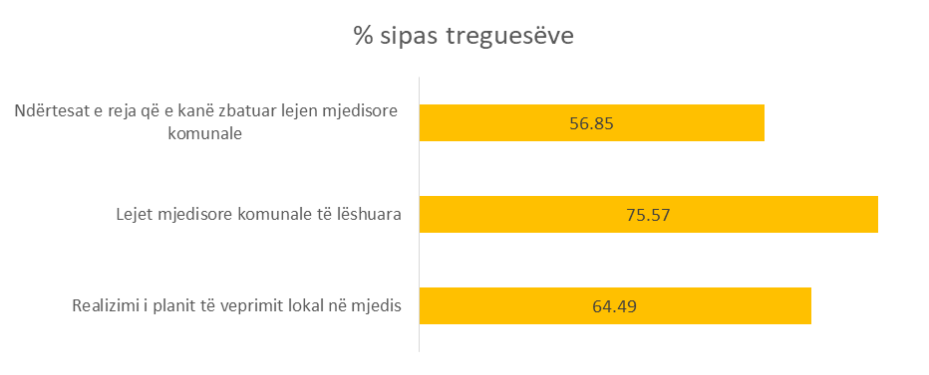

% by indicators

New buildings that have applied for a municipal environmental permit

Municipal environmental permits issued

Realization of the local action plan in the environment

The realization of the environmental action plan turns out to have reached the extent of 64.49%. The issued environmental permits were at the rate of 75.7% whereas the new buildings that have implemented the municipal environmental permit are at a very low rate of 56.85%.

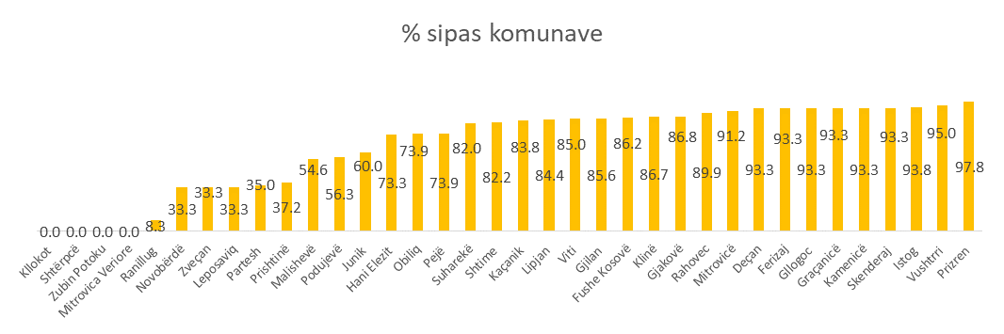

% by municipalities

Figure 32. Comparative data between municipalities in the field of environmental protection

## Field 16 – Gender Representation

Although a new area in the MPMS, there have been indicators of gender representation in previous measurements. However, gender representation is now more widely measured in this area, including the access of both genders to social and economic development programs, as well as to municipal activities. Also, the indicators measure the degree of representation of both genders in local institutions, bodies of municipal assemblies, etc. Despite the progress of municipalities over the years in ensuring equal representation in the bodies of assemblies and in municipal committees, the data for certain indicators minimize the percentage in this area making it quite low, 38.24%. In the following, the figure of gender representation according to the indicators is presented as follows:

Registration of property in the name of both sexes

Gender equality in naming streets

Municipal Gender Equality Plan

Participation of women in public meetings

Gender equality in budgeting for employment and entrepreneurship of women

Responsible gender budgeting and expenditure

Gender equality in the composition of local communities

Gender equality among members of municipal boards

Women appointed to political positions in the municipality

Women in management positions in educational, health and cultural / sports institutions

Women employed in municipal institutions / administrations

% by indicators

Figure 33. % of indicators in the field of gender equality [9]

Based on the data reported by 36 municipalities, out of a total of 37,310 employees in municipal institutions, 17,660 of them are women, or 80.66% of the legal criterion 50x50. Also, 23 municipalities proved to have drafted the plan for gender equality, while 13 municipalities did not prove that the plan was drafted.[10] In regards to political positions, out of 420 positions within the municipal executive, 119 are women, or 50.95% of the legal criteria in 36 municipalities. The percentage of representation in the bodies of municipal assemblies is 65% of the criterion. Based on the data on the representation of women in leading positions in educational, health and cultural/sports institutions, out of 1663 leading positions, 516 of them are led by women, or 59.02% of the fulfillment of the legal criteria. Gender equality is quite high in municipal institutions where on average 80.66% of municipalities meet the required standard.

Gender representation in local councils is extremely low and the vast majority of municipalities do not have any women leading these councils. This is also taking into account that almost half of the municipalities do not have functional local councils as shown in the third area. Gender representation in the names of municipal roads is extremely low as well as the registration of property in the name of a woman or both genders (husband or brothers and sisters).

% achieved by municipalities – gender representation

Figure 34 Comparisons by municipalities in the field of gender equality

Gender responsive budgeting and spending turns out to be done by just over half of the municipalities. However, there is a great need for training in this regard and as well the will of municipalities to understand the importance of this issue. Gender equality in budgeting for subsidies and the program of the municipality is at a very low level of 36.33% and this should be raised to the level of equality of 50%.

## Field 17 - Pre-University Education

This is a new field, first implemented in the 2019 reporting, consisting of 3 outcomes and 20 indicators. This indicator aims at results in spaces for kindergartens and schools equipped with internet cabinets, energy efficiency measures, recruitment of educational staff, teacher licensing, concretization tools, school equipment with teaching aids, ICT cabinets, as well as school safety conditions. This field has the overall performance at the level of 66.60%.

In general, in education indicators the data reported by municipalities have not been complete, so the percentages obtained may represent a relative value of accuracy. Out of a total of 115 public kindergartens in 16 municipalities as reported, in 15 of them 38 kindergartens were reported to be in rural areas[11]. Compared to the number of children reported living in these municipalities, 4.91% of those up to 3 years old attend the kindergarten [12], whereas 1.43% of children in rural areas [13]. 57.53% of schools meet the conditions with infrastructure, 50.89% of them have energy efficiency measures and 58.48% of primary schools turn out to be equipped with ICT cabinets. In addition, 64.19% of the schools in the 34 municipalities that reported were equipped with security measures, including fences and security cameras. Regarding school spaces, the national average is 11.49m2 per student in rural and urban areas.

In the 31 municipalities that reported, the level of compliance with the target student-to-teacher ratio, or 1 teacher per 26 students, is at 67.46%. Licensed teachers turn out to be 66.57%. Regarding the enrollment of students and the degree of their inclusion in the first grade, the municipalities have not provided accurate data for this indicator. Municipalities have reported a total of 93.97% of the implementation of the lesson plan.

Degree of realization of planned classes according to the annual educational calendar

Student dropout (inverse degree)

Gender Equality Index (for all ISCED levels 0-3)

Pass rate at the national matura cl.12 (division by gender)

Achievement test results for 9th cl.

Degree of access - transition 9th and 10th cl.

Gross degree of enrollment in the 1st grade

Kindergarten children - rural and general (division by gender)

Adherence to legal procedures for the selection of school management staff

Filling vacancies in education through a supplementary competition

Filling vacancies in education through a regular competition

Replenishment of the budget in education from own revenues

Level of compliance with the ratio of students per teacher - urban and…

Teachers who meet the criteria for a licensed qualification

Fulfilling the necessary conditions with infrastructure, equipment and resources in…

Security in pre-university institutions

Schools with energy efficiency measures

Schools equipped with IT cabinets

m² space for rural and urban students

Kindergartens and creeks in rural areas for 10,000 inhabitants

Indicators of the pre-university education - %

Figure 35. % of indicators in the field of pre-university education

The results for the achievement and passing of the national matura exam have been issued according to the reporting of 28 municipalities.

The completion of the budget for education from own source revenues is 7.04% which is close to the budget rate for primary health care from own source revenues.

% achieved by municipalities

Figure 36. Comparisons by municipalities in the field of pre-university education

## Field 18 – Primary Health Care

This is also a new area within the MPMS and is composed of 7 indicators. This field measures the infrastructure and spaces intended for primary health care, sufficient resources and staff, as well as the provision of services by the municipal level. According to data reported by municipalities, this field has a low level of performance in general, or in percentage 51.19%. The following is a figure with % of performance according to indicators in this field:

% of indicators

Providing specific health care to children and women

Children included in the immunization program

Number of visits to patients in primary health care per capita

Percentage of the budget for primary health care supported by municipalities from their own revenues

Level of compliance with the report 1 family doctor and 2 nurses for 2000 inhabitants

KPS facilities equipped according to the Administrative Instruction and laboratory services

m² KPS space for 10,000 inhabitants

Figure 37. % of indicators in the field of primary health care

Out of the total number of children who are of immunization age, 94.87% of them have declared themselves immunized.

36.40% of primary health care facilities meet the criteria with laboratory equipment and services according to the administrative instruction of the Ministry of Health No. 08/2017 MoH. Whereas, the ratio of family doctor as well as two nurses per 2000 inhabitants according to the standard is completed at the level of 69.61%. In 32 municipalities that have reported on the number of visits to primary health centers, the data show that 6,517,850 medical visits of patients have been made to these institutions, or an average of 3.79 visits per capita per year. 5.97% of the total budget for primary health care is covered by municipalities. 67.96% of primary health care institutions provide specific services for women and children.

% by municipalities

Figure 38. Comparisons by municipalities in the field of primary health care

## Field 19 – Local Economic Development

This is a new field and is implemented for the first time in this reporting cycle. The field consists of 1 outcome and 4 indicators. This field measures the activities planned and implemented for the development of economic activity at the local level by mobilizing municipal properties, and regular updating of the taxpayer register as well as collection of property tax at a high rate. This field has an overall performance of 59.35%.

Indicators in %

Level of collected property tax account (without debts, interests, penalties)

The level of the updated property tax register

Preparation for publishing the list of municipal property planned for use

Local Economic Development Plan

Figure 39. % of indicators in the field of local economic development

Over half of the municipalities reported on the drafting of plans for local economic development. Preparation and publication of the list of municipal properties is at a rate of 59.72%. Whereas, the update of the property tax register (standard of 20%) is fulfilled at a rate of 70.20%, whereas the property tax collection rate is 51.91%.

% by municipalities

Figure 40. Comparisons by municipalities in the field of pre-university education

# Conclusions and recommendations

The municipal performance assessment for 2019 brings out numerous findings for 19 fields of municipal competencies. The conclusions of this report highlight a large number of issues that need to be addressed and treated as priority by local governments. In this part of the report, some of the conclusions and recommendations with the greatest weight in the advancement of municipal services are singled out. The report concludes as follows:

1. The evaluation of the performance of municipalities for 2019 has been made possible for 36 municipalities. The Municipality of Mamusha and Dragas did not respond to this process. Performance measurement and evaluation is a legal obligation of all municipalities, which must respond to requests for information in accordance with the Law on Local Self Government and the Regulation on the Municipal Performance Management System. Some of the data reported by Serb-majority municipalities in the field of education and health, that did not correspond with the provision of services based on the legislation of the Republic of Kosovo, have been marked as void and a value of 0% of performance was applied. Performance measurement and evaluation is a legal obligation applied to all municipalities, thus municipalities must respond to the requests for information in accordance with the Law on Local Self-Government and the Regulation on the Municipal Performance Management System.
2. Despite the pandemic situation, the quality of reporting has been relatively good. Municipalities should pay attention to all data presented for reporting, so that the values obtained represent the most objective performance evaluation for each indicator.
3. Documentation of data is a necessary condition. When preparing data and information, municipalities should prepare a file for each field. The quality assurance process has identified a number of inaccurate data, which in many cases have been declared invalid, except when they have been documented.
4. The quality of reporting should be increased in the future, so that reporting is fair, accurate, and objective which also presents the most realistic state of performance of municipalities.
5. Performance data confirm the superiority of the field of disaster management over other fields. Municipal transparency ranks second, although the indicator for reflecting the outcomes of public consultations needs to be taken seriously by local authorities. Municipalities need to start implementing new minimum standards for public consultation. Reports of public consultation processes should be compiled to promote citizen participation in policy-making and obtaining their opinion on public issues.
6. There is also a need to standardize the use of official municipal websites. Information, reports and documents are placed in inappropriate menus, making access to information very difficult. The publication of documents should be done according to specific menus (applications) for certain materials.
7. The area with the lowest performance is sewerage. In this area, municipalities have not provided valid data on the number of settlements included in the wastewater treatment system. The high inaccuracy of the data has caused for this indicator to be declared void as a whole, so as not to reflect false performance.
8. A number of the municipalities have started the online application of administrative services. These services should be applied in all municipalities and for a greater number of services, including online application for building permits, environmental permits, property tax payments, or utility bills;
9. Only 27.78% of the municipalities substantiated to have discussed the integrity plan in the Municipal Assembly, 32% the internal auditor's report and 50% the Municipal Performance Report for the previous year. These plans and reports should become routine discussion points each year in municipal assemblies in order to strengthen the level of responsibility and accountability of the executive to the assembly and the citizens.
10. Data on social services show that municipal directorates should be more effective in assessing families in social housing, so that social housing facilities are used by families in need and there is a full review of the submitted requests;
11. Spatial planning requires more extensive treatment to regulate all necessary surfaces with detailed regulatory plans. The data show a very low scale of these plans which are extremely important for the regulation of the municipality;
12. Road infrastructure must be completed, both in terms of paving roads and with ancillary infrastructure including sidewalks and public lighting. Municipal directorates for infrastructure should better plan activities for summer and winter maintenance of local roads, through contracting relevant operators.
13. Also, municipalities should work on advancing road infrastructure through the creation of bicycle tracks, especially in urban areas, as well as the widening of sidewalks for rural settlements;
14. Municipalities should plan and cooperate to ensure wastewater treatment in parallel with the expansion of the sewerage network. Wastewater treatment is extremely low, given the high cost of this service. Municipalities should also consider the possibilities of other financial resources for the establishment of plants, in order to avoid numerous environmental problems and to protect public health.
15. The amount of waste disposal in Kosovo municipalities is quite low compared to the European Union average (per capita) and municipalities should ensure that the collected waste is disposed in a legal landfill and that it does not end up in an illegal landfill where it is not registered as a disposed quantity.
16. During the budget planning process, municipalities should compile and formulate the section of gender-responsive budgeting according to legal criteria. Local policies need to assess gender impact so that financial resources are allocated proportionately to both genders. Greater promotion of gender policies in local councils is required. About 33% of municipalities need to develop gender equality plans. The criterion of gender equality should be strengthened even within the appointed political positions, as well as to promote the right to the registration of ownership in both genders which remains at a very low value.
17. Municipalities should start investing in nurseries/kindergartens in rural areas where needed, due to the importance of these institutions in the early childhood development of children.
18. Municipal education directorates should plan for schools to meet the requirements of ancillary infrastructure, energy-efficient measures, as well as to be equipped with cabinets with internet to a greater extent. The creation of school spaces especially in urban areas require special treatment to eliminate teaching in more shifts and to apply all-day learning.
19. The standard of one family doctor and two nurses per 2000 inhabitants should be achieved to a greater extent, as it is an important standard for public health under the management of the municipality;
20. Formal planning for local economic development should be expanded to municipalities. Reporting on the implementation of such plans should be a topic of discussion in municipal assemblies, so that activities in this field can be more easily implemented and prioritized according to the requirements of the majority.

# Annex: % of indicators by fields

|  |  |  |  |
| --- | --- | --- | --- |
| ADMINISTRATIVE SERVICES | 1.1.1 | Administrative requests reviewed during the year | 92.66 |
| 1.1.2 | Administrative requests reviewed within legal deadlines | 88.19 |
| 1.1.4 | Administrative services provided electronically by the municipality | 30.56 |
| MUNICIPAL TRANSPARENCY | 2.1.1 | Assembly meetings made public and broadcast live online | 59.13 |
| 2.1.2 | Level of citizens' access to public documents | 87.31 |
| 2.1.3 | Meeting the criteria of the official website of the municipality | 70.83 |
| 2.1.4 | Publication of acts adopted by the municipal assembly in the official website of the municipality | 77.37 |
| 2.1.5 | Publication of acts of general character, approved by the mayor on the official website of the municipality | 64.79 |
| 2.2.1 | Publication of documents for budget planning and expenditure | 77.78 |
| 2.2.2 | Publication of public procurement documents and contracts | 70.18 |
| MUNICIPAL ACCOUNTABILITY | 3.1.1 | Publication of announcements for holding 2 public meetings | 83.33 |
| 3.1.2 | Citizen's participation in public consultations | 53.79 |
| 3.1.3 | Municipal acts and local policy documents consulted with the public | 67.15 |
| 3.1.4 | Public hearings on MTEF and municipal budget | 90.51 |
| 3.1.5 | Publication of reports on public consultation processes | 0.00 |
| 3.1.6 | Local councils that have held at least 6 (six) meetings annually | 54.11 |
| 3.1.7 |  | 57.68 |
| 3.1.8 | Interventions in sewage overflow | 65.11 |
| 3.2.1 | Timely approval of the annual municipal draft budget | 88.61 |
| 3.2.2 | Discussions on quarterly budget reports by the Municipal Assembly | 84.72 |
| 3.2.3 | Discussion on municipal performance report by the municipal assembly for the previous year | 50.00 |
| 3.2.4 | Discussion of the external auditor's report and action plan for addressing the recommendations in the Municipal Assembly | 75.00 |
| 3.2.5 | Discussion of the internal auditor's report and action plan in the Municipal Assembly | 31.94 |
| 3.2.6 | MA meetings with the participation of the mayor | 62.24 |
| 3.3.1 | Level of implementation of the procurement plan | 77.64 |
| 3.3.2 | Level of payments processed within the legal deadline of 30 days | 73.61 |
| 3.3.3 | Level of addressing the recommendations of the National Audit Office | 30.13 |
| 3.4.1 | Reporting the annual plan of the integrity plan before the Municipal Assembly | 27.78 |
| 3.4.2 | Suspended municipal officials in relation to charges filed against them | 93.06 |
| 3.5.1 | Implementation of the scheme for the distribution of job evaluations for civil servants | 72.56 |
| 3.5.2 | Job vacancies processed through HRMIS | 83.62 |
| 3.5.3 | Specific service contracts are in line with the legal framework | 50.12 |
| EMPLOYMENT EQUALITY, SOCIAL AND FAMILY SERVICES | 4.1.1 | Employees with disabilities in municipal institutions | 23.19 |
| 4.1.2 | Employees of non-majority communities | 59.38 |
| 4.2.1 | Families in need which have been provided with housing and conditions have been created to launch social housing | 60.28 |
| 4.2.2 | Children in need of housing provided with family housing | 85.34 |
| CULTURE, YOUTH AND SPORT | 5.1.1 | Space for sports activities per capita | 67.68 |
| 5.2.1 | Culture, youth and sports activities organized with municipal budget | 79.23 |
| 5.2.2 | Citizen participation in activities for culture, youth and sports | 57.37 |
| DISASTER MANAGEMENT | 6.1.1 | Level of implementation of the municipal disaster management plan | 68.48 |
| 6.1.2 | Disaster protection interventions | 85.90 |
| MUNICIPAL SPATIAL PLANNING | 7.1.1 | Area of the municipality covered by (detailed) regulatory plans | 14.05 |
| 7.2.1 | Applications Reviewed for construction permits | 85.55 |
| 7.2.2 | New buildings inspected | 73.86 |
| 7.2.3 | New facilities with construction permits | 69.86 |
| PUBLIC SPACES | 8.1.1 | Area of public green spaces in m2 per capita | 11.88 |
| 8.1.2 | The area of regularly maintained public spaces | 67.46 |
| 8.1.3 | Public spaces equipped with public lighting | 75.40 |
| ROAD INFRASTRUCTURE | 9.1.1 | Paved local roads | 71.83 |
| 9.1.2 | Local roads maintained during the summer season | 54.57 |
| 9.1.3 | Local roads maintained during the winter season | 64.98 |
| 9.2.1 | Length of local roads equipped with sidewalks | 9.15 |
| 9.2.2 | Length of local roads equipped with public lighting | 15.03 |
| 9.2.3 | Length of local roads equipped with vertical and horizontal signage | 52.61 |
| 9.2.4 | Roads in the urban area with bicycle tracks | 5.89 |
| 9.2.5 | Re-paved local roads | 66.00 |
| PUBLIC TRANSPORTATION | 10.1.1 | Implementation of the municipal plan for local public transport | 66.55 |
| 10.1.2 | Settlements covered with local public transport | 65.47 |
| 10.1.3 | Marked stops for public transport vehicles | 60.38 |
| PUBLIC PARKING | 11.1.1 | Number of parking lots for parking motor vehicles | 26.03 |
| 11.1.2 | Parking lots for motor vehicles in the territory of the municipality | 15.22 |
| 11.1.3 | Parking lots intended for taxis | 55.62 |
| 11.1.4 | Number of parking lots with parking spaces reserved for people with disabilities | 50.40 |
| DRINKING WATER | 12.1.1 | Implementation of the plan for construction and maintenance of the water supply system | 72.33 |
| 12.1.2 | Households, public institutions and business units covered with the drinking water system | 73.87 |
| THE SEWAGE | 13.1.1 | Implementation of the plan for construction and maintenance of the sewerage system | 74.64 |
| 13.1.2 | Households, public institutions and business units included in the sewerage system | 71.42 |
| 13.2.1 | Settlements covered with the wastewater treatment system | 0.00 |
| WASTE MANAGEMENT | 14.1.1 | Implementation of the municipal waste management plan | 78.27 |
| 14.1.2 | Households that have access to the waste collection system | 70.10 |
| 14.2.1 | Implementation of waste collection schedule | 87.77 |
| 14.2.2 | Collection of funds for waste collection | 73.35 |
| 14.3.1 | Amount of waste disposal in kilograms per capita | 50.35 |
| ENVIRONMENTAL PROTECTION | 15.1.1 | Implementation of the local environmental action plan | 64.49 |
| 15.1.2 | Municipal environmental permits issued | 75.57 |
| 15.1.3 | New buildings that have implemented the municipal environmental permit | 56.85 |
| GENDER REPRESENTATION | 16.1.1 | Women employed in municipal institutions / administration | 80.66 |
| 16.1.2 | Women in leadership positions in educational, health and cultural / sports institutions | 59.02 |
| 16.1.3 | Women appointed in political positions in the municipality | 50.95 |
| 16.1.4 | Gender equality among members of municipal committees | 65.08 |
| 16.1.5 | Gender equality in the composition of local councils | 6.40 |
| 16.2.1 | Gender-responsive budgeting and expenditure | 51.39 |
| 16.2.2 | Gender equality in budgeting women's employment and entrepreneurship | 36.33 |
| 16.2.3 | Women's participation in public meetings | 47.11 |
| 16.2.4 | Municipal plan for gender equality | 66.67 |
| 16.3.1 | Gender equality in street names | 11.67 |
| 16.3.2 | Registration of ownership in the name of both spouses | 12.17 |
| PRE-UNIVERSITY EDUCATION | 17.1.1 | Nurseries and kindergartens in rural areas per 10000 inhabitants | 1.00 |
| 17.1.2 | sm2 of space per student - urban and rural | 42.25 |
| 17.1.3 | Schools equipped with ICT cabinet | 58.48 |
| 17.1.4 | Schools with energy efficiency measures | 50.89 |
| 17.1.5 | Security in pre-university education institutions | 64.19 |
| 17.1.6 | Meeting the required conditions with infrastructure, equipment and tools in pre-university education institutions | 57.53 |
| 17.2.1 | Teachers who meet the criteria for a licensed qualification | 83.29 |
| 17.2.2 | Level of compliance with the student -teacher ratio at urban and rural level | 67.46 |
| 17.2.3 | Filling of the budget for education from own source revenues | 7.04 |
| 17.2.4 | Filling vacancies in education with regular competition | 87.61 |
| 17.2.5 | Filling vacancies in education with additional competition | 90.47 |
| 17.2.6 | Adherence to legal procedures for the selection of school management staff (principals and deputy principals) | 91.11 |
| 17.3.1 | Children attending kindergarten - rural and general (disaggregated by gender) | 4.91 |
| 17.3.2 | Gross enrolment rate in grade 1 | 94.51 |
| 17.3.3 | Degree of access - transition G9- G10 | 93.91 |
| 17.3.4 | Achievement test results for 9th grade | 59.52 |
| 17.3.5 | Passing rate in the national matura 12th grade (disaggregated by gender) | 74.62 |
| 17.3.6 | Gender Equality Index (for all ISCED levels 0-3) | 79.45 |
| 17.3.7 | Student dropout (inverse rate) | 97.17 |
| 17.3.8 | Degree of realization of the planned hours according to the annual calendar of education | 93.97 |
| PRIMARY HEALTHCARE | 18.1.1 | sm2 of PSC space per 10000 inhabitants | 71.48 |
| 18.1.2 | PSC facilities that are equipped according to the administrative instruction and laboratory services | 36.40 |
| 18.2.1 | Level of compliance with the ratio 1 family doctor and 2 nurses per 2000 inhabitants | 69.61 |
| 18.2.2 | Percentage of the budget for primary health care supported by municipalities from own source revenues | 5.97 |
| 18.3.1 | Number of patient visits to primary health care per capita | 36.78 |
| 18.3.2 | Children involved in the immunization program | 94.87 |
| 18.3.3 | Provision of specific health care for women and children | 67.96 |
| LOCAL ECONOMIC DEVELOPMENT | 19.1.1 | Local economic development plan | 55.56 |
| 19.1.2 | Preparation and publication of the list of municipal properties planned for allocation for use | 59.72 |
| 19.1.3 | Level of updating the property tax register | 70.20 |
| 19.1.4 | Level of property tax bill collection (without debts, interest, penalties) | 51.91 |

1. Regulation No.01 / 2020 on the Municipal Performance Management System, article 5.1.1
2. The development of indicators was carried out in cooperation with the relevant ministries, namely the Ministry of Education, the Ministry of Health and the Ministry of Economic Development
3. In fields such as water supply and waste management, measurment components are limited to those actions which relate to the exclusive competencies of municipalities. Indicators do not measure qualitative aspects of these services, but are limited to mainly in the scope of the service. So, it is not measured how many citizens have drinking water, but If this service is provided to all entities. Water supply currently contains indicators that measure the level of planning and implementation of municipal projects in this area and the extension of the drinking water system to households, public institutions and business economies, but not the collection of funds which belongs to regional water companies which are owned by the central level. The same was done with waste management, knowing that the extension of this service only does not sum up the success of the whole field. In the future, this area should be expanded with quality management indicators, which may include waste separation at source, disposal for all types of waste and their processing (recycling). Considering that waste management is a mixed competence between the local and central level, at this stage, measurement and evaluation is limited to the level of implementation of the municipal plan for waste management, extension of the waste collection system according to households, implementation of waste collection schedule, level of collection of waste collection facilities and the amount of waste disposal.
4. Based on Article 17 of the AI No.06/2018 on Minimum Standards for Public Consultations in Municipalities
5. Fushe Kosova, Gracanica, Kllokot, Novo Brdo, Partes, Ranilug, Strpce, Zubin Potok, Zvecan, Leposavic, North Mitrovica.
6. Municipalities of Strpce, Zubin Potok, Zvecan; Leposavic, North Mitrovica and Klina did not provide information on the number of vehicles registered in the municipality.
7. The municipality of Zubin Potok and Kllokot did not provide data on the number of households in the municipality
8. https://ec.europa.eu/eurostat/statistics-explained/index.php/Municipal_waste_statistics
9. The 50% level is considered a full achievement of representation based on the Law on Gender Equality
10. Gjilan, Graçanicë, Hani I Elezit, Klinë, Novobërdë, Podujevë, Ranillug, Shtërpcë, Viti, Zubin Potok, Zveçan, Leposaviq.
11. The municipalities that have declared kindergartens in rural areas are as follows: Decan (1), Gjilan (1), Gllogoc (1), Gracanica (3), Kamenica (1), Klina (1), Kllokot (3), Junik (1), Prishtina (2), Rahovec (1), Ranillug (5), Strpce (2), Skenderaj (1), Suhareka (2), Zubin Potok (4),
12. According to data provided by 23 municipalities
13. Data were reported from 10 municipalities