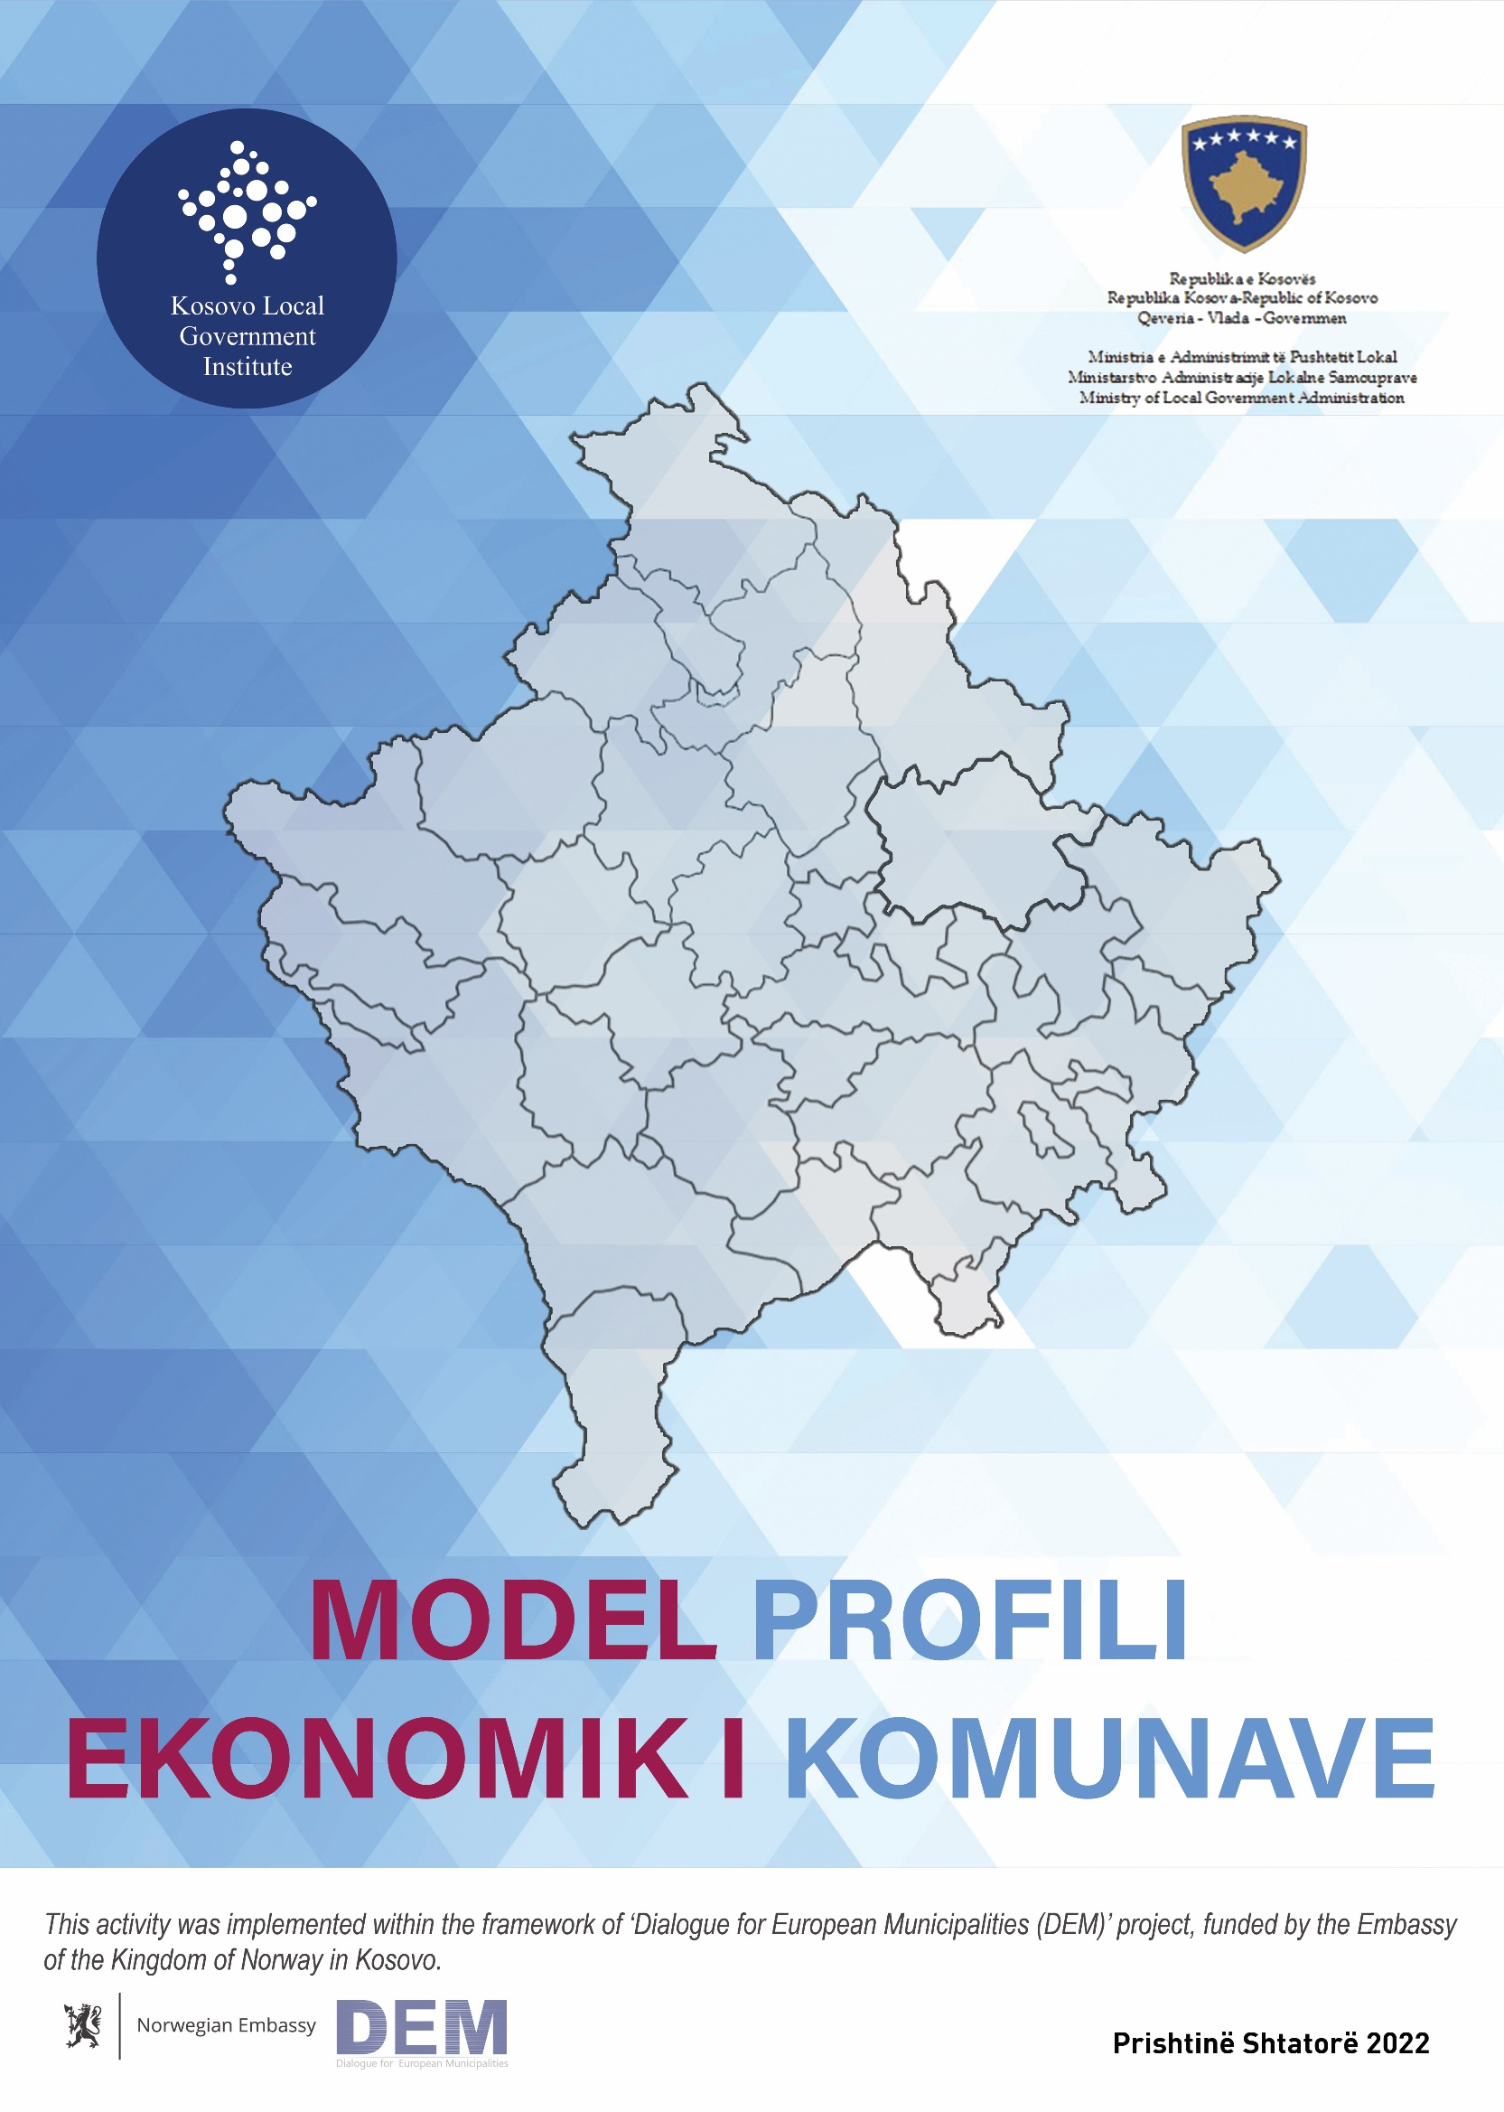

NA
MODEL OF THE ECONOMIC PROFILE OF MUNICIPALITIES

Pristina, september 2022.
Summary

Economic development at the country level, has been faced with many problems and challenges, which need to be addressed through government strategies and action plans. At the local level, to these challenges are joined specific problems for each municipality, which cause various obstacles for economic development. Based on the Law on Local Self-Government, municipalities have full and exclusive competencies as regard to the local interest, where the area of local economic development is also precisely defined..
The local level is facing with many challenges in various areas where the creation of a favorable climate for attracting foreign direct investments remains unaddressed. Municipalities are responsible for creating a climate and a favorable business making environment, for the purpose of local economic development In order to have a local economic development In this regard, the Strategy for Local Economic Development 2019-2023 has foreseen several strategic objectives to address this problem.
In this regard, the Ministry of Local Government Administration has drawn up a model of the economic profile of municipalities in order to develop profiles in the form of brochures, to raise foreign direct investments (FDI) at the local level. This document includes a broad description of the goals and results of drafting economic profiles for municipalities, aiming to raise awareness at the central and local level about the importance of FDI. Also, this document presents a model of the economic profile with all important aspects, where each municipality shall use it as a basis for drafting economic profiles. The model of economic profile of the municipalities is an informative document, without deadline, which aims attracting attention of national and international investors. Municipalities can draft a model in online versions, as well.

Purposes of Economic Profile
Drafting the economic profiles of municipalities aims to attract investments from foreign and local investors, in order to contribute in economic development of the municipality. Economic profiles of municipalities cannot be successful without commitment in all areas at the local level. First, municipalities must have a comprehensive and well-build policy, where they can issue different and clear programs, where in which will be included various and clear programs, which are divided according to the respective fields, starting from:

  - investment in human resources;
  - preservation and advancement of existing businesses;
  - attraction of new businesses;
  - planning and determining areas for investment;
  - providing a safe and suitable environment for foreign direct investments;
  - adoption of modern technologies;
  - management of resources;
  - utilization of unused land.

All these areas are necessary to increase investments from foreign investors. In order to have more FDI, the municipality should have a good management of human and financial resources, to create spaces for investment and facilitate processes and environment for investment. The purpose of attracting foreign investments is the opening of new jobs and the great impact on budget revenues and in the general economic development of the municipality; concentrating of businesses in a certain place and their promotion, expanding cooperation between businesses, creating conditions for businesses in order to have easier access, increasing competition at the local and international business; accelerating regional development and expansion of the market economy ties.
There are many different areas that are attractive to investors, but tourism is one of the most suitable areas toattract foreign investment, attract new investors, attract tourists by offering access to natural resources and natural beauties, access to services, access to other tourist values, cultural heritage and others. The direct impact of tourism leads to an increase in revenues, the development of economic activities that make up the tourist economy including: hotels, transport, trade, cultural institutions, employment growth, living standard, investments and the development of underdeveloped areas, mountain tourism, cultural ( artistic feasts, fairs, concerts , festivals, museums), family tourism, winter and youth tourism, ecotourism and many other fields.

Results of the economic profile
The key results of local economic development are the improvement and increase in the quality of life of citizens by offering new opportunities for the operation of businesses, the promotion of production especially in the agricultural sector (which generates seasonal employment), creating conditions for better movement of people and goods; improving the standard of living, supporting certain social categories as well as other forms of support for economic and social activities.
With the drafting of the economic profiles of municipalities, investments from new and foreign investors would increase significantly. In this regard, increasing the level of foreign direct investments will make the local economy cover financial needs and create better living conditions for citizens. This means that foreign businesses must find adequate support from municipalities to invest at the local level.
In order to draw up economic profiles, the municipalities will increase the level of knowledge regarding foreign investment opportunities, and address this issue as a priority, so that investors will have clear addresses regarding their interests. Likewise, the research that will be occur during the drafting of economic profiles will open different views, where municipalities can find opportunities on facilitating municipal services, improving and increasing the quality of life of citizens, by offering new opportunities for the operation of businesses, the promotion of production especially in the agricultural sector (which generates seasonal employment), creating conditions for better movement of people and goods; improving the standard of living, supporting certain social categories as well as other forms of support for economic and social activities in order to encourage foreign direct investments.
These profiles will directly contribute to the implementation of the objectives of the Strategy for Local Economic Development 2019-2023. More specifically, this would contribute to the specific objective of the strategy related to this area, which aims to attract foreign investment by creating more favorable conditions for foreign investors, operationalizing balanced economic zones and increasing municipal transparency in function of creating conditions for foreigners investments.
As a result of drafting the economic profiles of the municipalities, the municipalities will:
  - analyze all areas where facilitation for FDI is necessary;
  - identify the steps for creating the conditions for FDI;
  - identify the sectors which have most potential for FDI;
  - promote the municipality's potential for new investors in Kosovo;
  - promote the potential of the municipality for Diaspora and foreign investors;
  - create a single contact address for investors.

Model

THE ECONOMIC PROFILE OF MUNICIPALITY XX

The speech of the Mayor of Municipality

[Name of the municipality ] a review

Mission of the municipality

Demography  [ Population based on specific data according to::  - gender  - age with a focus on the young people  - ethnicity] |  | Settlements  - [Numer of settlements]
Surface of the municipality [XX] [a picure from the map]

Budget of the municipality:
Public properties for use (with photos)
Education
- Number of schools/kindergartens
- Number of children in pre-education
- Number of students in primary/secondary schools
- Number of students at the University in cities (if any))
The Healthcare
- MCFM
- Hospitals (if any)
- Percentage of immunization
- Units in the villages
Access to basic services
Water supply Electrial energy Internet housing sewage

[[percentage of houses in all services]]

The municipal safety
The three largest sectors (according to the municipality assessment )
[sector 1] | [sector 2] |  | [sector 3]

Demography
[It should not be more than half a page. The purpose of describing the demographics should be, to give an overview to investors regarding the number of young men and women as potential workers. The information about the population density in cities and villages should also be added]
Description of the population of the municipality
[graphs with correct data]

Organizational structure of municipality
[It should not be more than half a page. The information related to the executive, assembly, directorates, sectors and units. The purpose of the description is to show investors accurate data, when they want to invest in the municipality]

Executive Municipal Assembly

Directorates Units and Sectors

[investor contacts should be written here]
[facilitated administrative processes for investors, if any, should be highlighted.]

Budget
[A simple table that specifies the municipal budget, clearly showing own revenues, other revenues, investments, and expenses. The data should focus on informing potential investors about the economic stability of the municipality. The table should be as simple as possible for readers and should not exceed 2/3 of the page]

Employment
[The number of employees in the public and private sector as well as the number of unemployed with accurate data according to gender and age. This data should be presented in a table or in the simple pictures and they should not exceed half of the page.]

Education
[It should not be more than half a page. Educational institutions (number of schools), the number of students at all levels with accurate data, school infrastructure (including digitization), all necessary information according to the municipality's assessment in order to attract investors.]

Health
[It should not be more than half a page. Health institutions (number of MCFM and hospitals if any), in all villages, types of services provided (including home services.]

Culture, Sport and Youth
[It should not be more than one page. The potential for culture, sports and youth in the municipality should be listed; listing of municipal properties related to cultural and sports activities, festivals, museums, concerts, etc. which are part of the municipality's field. Also, this section should use as many attractive pictures as possible from these events]
[The section on culture, youth and sports should also include a brief history of the municipality, focusing on the most important dates of various events that investors can attend]

Economy
[This part is the most important part for foreign investors. It should not be more than one page and should contain information related to:
- Economic sector performance (production, investments, employment level)
- The most developed sectors of the economy in the municipality (including some success stories)
- Less developed sectors in the municipality (including here potencial for development)
- Public properties, which can be used for local economic development purposes.
- Salary rates in the public and private sectors (including average salaries in the public and private sectors)
- The cost of production of products, which are produced in that municipality.
- Products which have a comparative advantage and that the investment will contribute to local economic development]

Safety
[Add information related to safety in the municipality, no more than half a page.]

Agriculture
[In order to attract investors, in this part should be added information related to agricultural land, production, agricultural products, comparative advantage if any. It should not be more than half a page.]

Environment
[This part should include information about the land, water, air and climate in that municipality. The information is important to connect it with the part of agriculture in order to raise attention to cultivation. It should not be more than half a page]

Infrastructure and transport
[This section should firstly provide information regarding the municipal infrastructural spreading. In this section the municipality should also list all regional and national roads and connections of the municipality with other cities and countries. In particular, with a special focus on proximity to the border, airport, port, etc. It should not be more than one page]

Tourism
[Tourism is one of the most attractive fields for foreign investors, and the potential of Kosovo municipalities to attract investors in this field is high.
This branch should be developed and promoted more by the municipalities, in order to utilize different forms of tourism development, including: mountain tourism, cultural ( artistic feasts, fairs, concerts , festivals, museums), family tourism, winter and youth tourism as well as ecotourism and many other fields. The municipality should also add information and pictures about the most attractive activities for that municipality, such as Vine festival in the Municipality of Rahovec, tomato festival in the Municipality of Mamusha, etc. There are no page limits and that the municipality can use pictures].

CONTACTS

